MGMS – Asset Purchase

Detailed Design Document

Ver. 1.4

Version History
Date | Description
12-Nov-2010 | First Draft

Table of Contents

Version History 2
1 Introduction 4
2 Asset Management 4
3 Associated tables 7
4 Data Dictionary 7

Introduction

This document provides the detailed design specifications for the Multisite Grant Management System project.

This is not a project plan nor does it detail the source code. It is a guide for system architecture and development, not for phasing, timelines or deliverables.

Finally, this is a ‘living document’ and the specification will change, continuously, as the project proceeds. More details will be added and the existing information edited as the requirements, architecture and design evolve in the course of the project.

Asset Management

In Asset Management module, equipment purchase details can be recorded against each project.

For each purchase, details saved include: item name, asset code, order no:, received date, bill no:, cost and user’s remarks, if any.

Clicking on the Asset Management menu on the left panel will open the Current Projects list screen, as shown below:

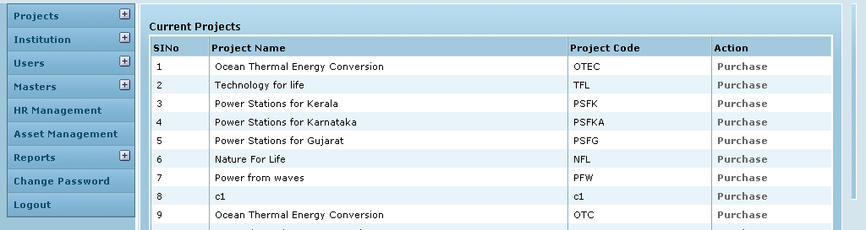

Screen & Control Description

Field /Label | Input-Control | Data Type | DB Table>Field
Sl No | Auto generated sequential numbering for each row
Project Name | Auto populated | varchar(255) | projects>name
Project Code | Auto populated | varchar(255) | projects>code
Action | “Purchase” link | link

Clicking on Purchase for a particular project will open the Project Item Purchase screen as shown below:

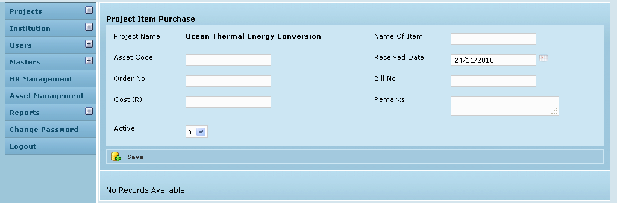

Screen & Control Description

Field /Label | Input-Control | Data Type | DB Table>Field
Project Name | Auto populated | varchar(255) | projects>name
Name of item | Textbox | varchar(255) | item_purchase>name
Asset Code | Textbox | varchar(255) | item_purchase>asset_code
Received Date | Calendar | datetime | item_purchase>date_received
Order No: | Textbox | varchar(255) | item_purchase>order_no
Bill No: | Textbox | varchar(255) | item_purchase>bill_no
Cost | Textbox | varchar(255) | item_purchase>cost
Active | Listbox | varchar(255) | item_purchase>status
Remarks | Text area | varchar(255) | item_purchase>remarks
Save | Button

When there are no saved records, a message is displayed on the screen as shown above – “No records available”

Each time a record is saved, the screen is refreshed with a message – “Created Successfully” and the details y are displayed in table format as shown in the screen below:

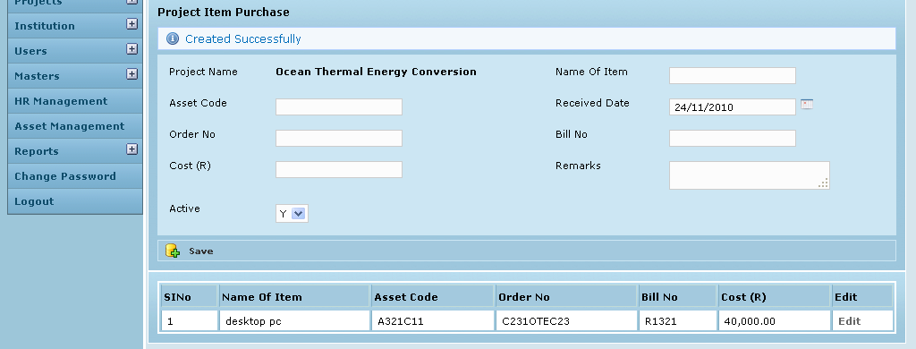

Field /Label | Input-Control | Data Type | DB Table>Field
Sl No | Auto increment sequential
Name of item | Textbox | varchar(255) | item_purchase>name
Asset Code | Textbox | varchar(255) | item_purchase>asset_code
Order No: | Textbox | varchar(255) | item_purchase>order_no
Bill No: | Textbox | varchar(255) | item_purchase>bill_no
Cost | Textbox | varchar(255) | item_purchase>cost
Edit | “Edit” | Link

Clicking on Edit for a particular purchase item lien in the table will open the Edit Item Purchase screen as shown below:

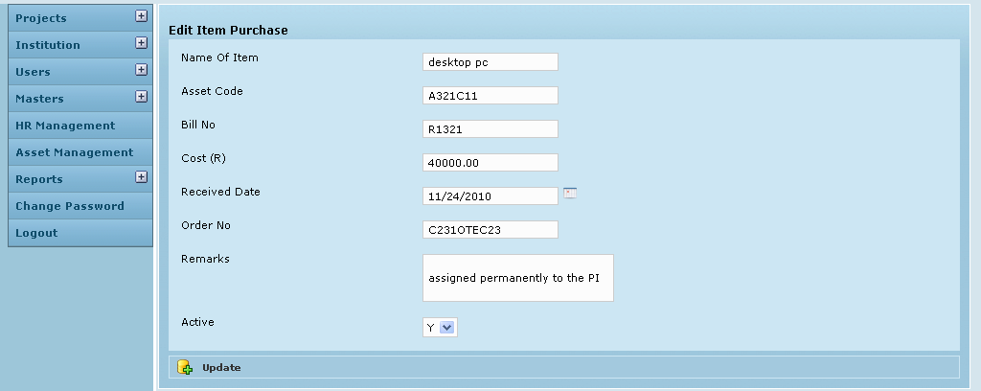

Screen & Control Description

Field /Label | Input-Control | Data Type | DB Table>Field
Project Name | Auto populated
Name of item | Auto populated editable textbox | varchar(255) | item_purchase>name
Asset Code | Auto populated editable textbox | varchar(255) | item_purchase>asset_code
Received Date | Auto populated editable calendar | datetime | item_purchase>date_received
Order No: | Auto populated editable textbox | varchar(255) | item_purchase>order_no
Bill No: | Auto populated editable textbox | varchar(255) | item_purchase>bill_no
Cost | Auto populated editable textbox | varchar(255) | item_purchase>cost
Active | Auto populated editable listbox | varchar(255) | item_purchase>status
Remarks | Auto populated editable textarea | varchar(255) | item_purchase>remarks
Update | Button

Associated tables

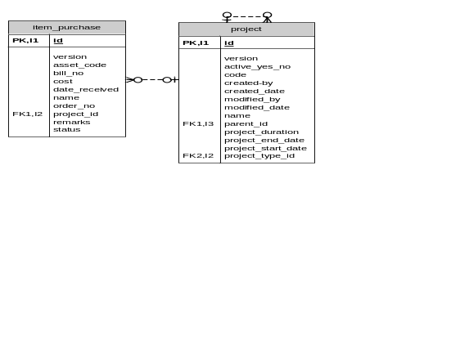

Data Dictionary

item_purchase

Fields

Field | Type | Collation | Null | Key | Default | Extra | Privileges | Comment
id | bigint(20) | (NULL) | NO | PRI | (NULL) | auto_increment | select,insert,update,references
version | bigint(20) | (NULL) | NO |  |  |  | select,insert,update,references
asset_code | varchar(255) | latin1_swedish_ci | NO |  |  |  | select,insert,update,references
bill_no | varchar(255) | latin1_swedish_ci | NO |  |  |  | select,insert,update,references
cost | double | (NULL) | NO |  |  |  | select,insert,update,references
date_received | datetime | (NULL) | NO |  |  |  | select,insert,update,references
name | varchar(255) | latin1_swedish_ci | NO |  |  |  | select,insert,update,references
order_no | varchar(255) | latin1_swedish_ci | NO |  |  |  | select,insert,update,references
projects_id | bigint(20) | (NULL) | NO | MUL |  |  | select,insert,update,references
remarks | varchar(255) | latin1_swedish_ci | NO |  |  |  | select,insert,update,references
status | varchar(255) | latin1_swedish_ci | NO |  |  |  | select,insert,update,references

Indexes

Table | Non  unique | Key  name | Seq  in  index | Column  name | Collation | Cardinality | Sub  part | Packed | Null | Index  type | Comment
item_purchase | 0 | PRIMARY | 1 | id | A | 15 | (NULL) | (NULL) |  | BTREE
item_purchase | 1 | FK7F0A80AD905C4B9A | 1 | projects_id | A | 15 | (NULL) | (NULL) |  | BTREE

Foreign Key Relationships

FK Id | Reference Table | Source Column | Target Column | Extra Info
FK7F0A80AD905C4B9A | projects | `projects_id` | `id`

projects

Fields

Field | Type | Collation | Null | Key | Default | Extra | Privileges | Comment
id | bigint(20) | (NULL) | NO | PRI | (NULL) | auto_increment | select,insert,update,references
version | bigint(20) | (NULL) | NO |  |  |  | select,insert,update,references
active_yes_no | char(1) | latin1_swedish_ci | NO |  |  |  | select,insert,update,references
code | varchar(255) | latin1_swedish_ci | NO |  |  |  | select,insert,update,references
created_by | varchar(255) | latin1_swedish_ci | NO |  |  |  | select,insert,update,references
created_date | datetime | (NULL) | NO |  |  |  | select,insert,update,references
modified_by | varchar(255) | latin1_swedish_ci | NO |  |  |  | select,insert,update,references
modified_date | datetime | (NULL) | NO |  |  |  | select,insert,update,references
name | varchar(255) | latin1_swedish_ci | NO |  |  |  | select,insert,update,references
parent_id | bigint(20) | (NULL) | YES | MUL | (NULL) |  | select,insert,update,references
project_duration | varchar(255) | latin1_swedish_ci | YES |  | (NULL) |  | select,insert,update,references
project_end_date | datetime | (NULL) | YES |  | (NULL) |  | select,insert,update,references
project_start_date | datetime | (NULL) | YES |  | (NULL) |  | select,insert,update,references
project_type_id | int(11) | (NULL) | NO | MUL |  |  | select,insert,update,references

Indexes

Table | Non  unique | Key  name | Seq  in  index | Column  name | Collation | Cardinality | Sub  part | Packed | Null | Index  type | Comment
projects | 0 | PRIMARY | 1 | id | A | 137 | (NULL) | (NULL) |  | BTREE
projects | 1 | FKC479187A69DF6AED | 1 | project_type_id | A | 8 | (NULL) | (NULL) |  | BTREE
projects | 1 | FKC479187A43BA2D6A | 1 | parent_id | A | 137 | (NULL) | (NULL) | YES | BTREE

Foreign Key Relationships

FK Id | Reference Table | Source Column | Target Column | Extra Info
FKC479187A43BA2D6A | projects | `parent_id` | `id` | ,
FKC479187A69DF6AED | project_type | `project_type_id` | `id`

